NAME – Sarthak Kesarwani
USN -1NT19IS141

Intent: Implicit and Explicit Intent

IMPLICIT INTENT

Activity main .xml

<?xml version="1.0" encoding="utf-8"?>
<LinearLayout xmlns:android="http://schemas.android.com/apk/res/android"
xmlns:app="http://schemas.android.com/apk/res-auto"
xmlns:tools="http://schemas.android.com/tools"
android:layout_width="match_parent"
android:layout_height="match_parent"
android:background="#131212"
android:orientation="vertical"
tools:context=".MainActivity">
<TextView
android:layout_width="match_parent"
android:layout_height="wrap_content"
android:layout_marginTop="15dp"
android:layout_marginBottom="15dp"
android:gravity="center"
android:text="IMPLICIT"
android:fontFamily="serif-monospace"
android:textStyle="bold"
android:textColor="@color/purple_200"
android:textSize="50dp" />
<EditText
android:id="@+id/text"
android:layout_width="match_parent"
android:layout_height="wrap_content"
android:layout_marginLeft="20dp"
android:layout_marginTop="200dp"
android:layout_marginRight="20dp"
android:background="@color/white"
android:gravity="center"
android:hint="enter your number here"
android:textColor="@color/purple_500"
android:textSize="40dp"
android:textStyle="normal" /><Button
android:id="@+id/button"
android:layout_width="match_parent"
android:layout_height="wrap_content"
android:layout_margin="40dp"
android:text="CALL"
android:textSize="30dp" />
</LinearLayout>

MAINACTIVITY.JAVA
package com.example.implict;
import androidx.appcompat.app.AppCompatActivity;
import android.content.Intent;
import android.net.Uri;
import android.os.Bundle;
import android.view.View;
import android.widget.Button;
import android.widget.EditText;
public class MainActivity extends AppCompatActivity {
EditText text;
Button button;
@Override
protected void onCreate(Bundle savedInstanceState) {
super.onCreate(savedInstanceState);
setContentView(R.layout.activity_main);
text=findViewById(R.id.text);
button=findViewById(R.id.button);
button.setOnClickListener(new View.OnClickListener() {
@Override
public void onClick(View view) {
Uri myUri= Uri.parse("tel:"+text.getText().toString());
Intent it=new Intent(Intent.ACTION_DIAL,myUri);
startActivity(it);
}
});
}}

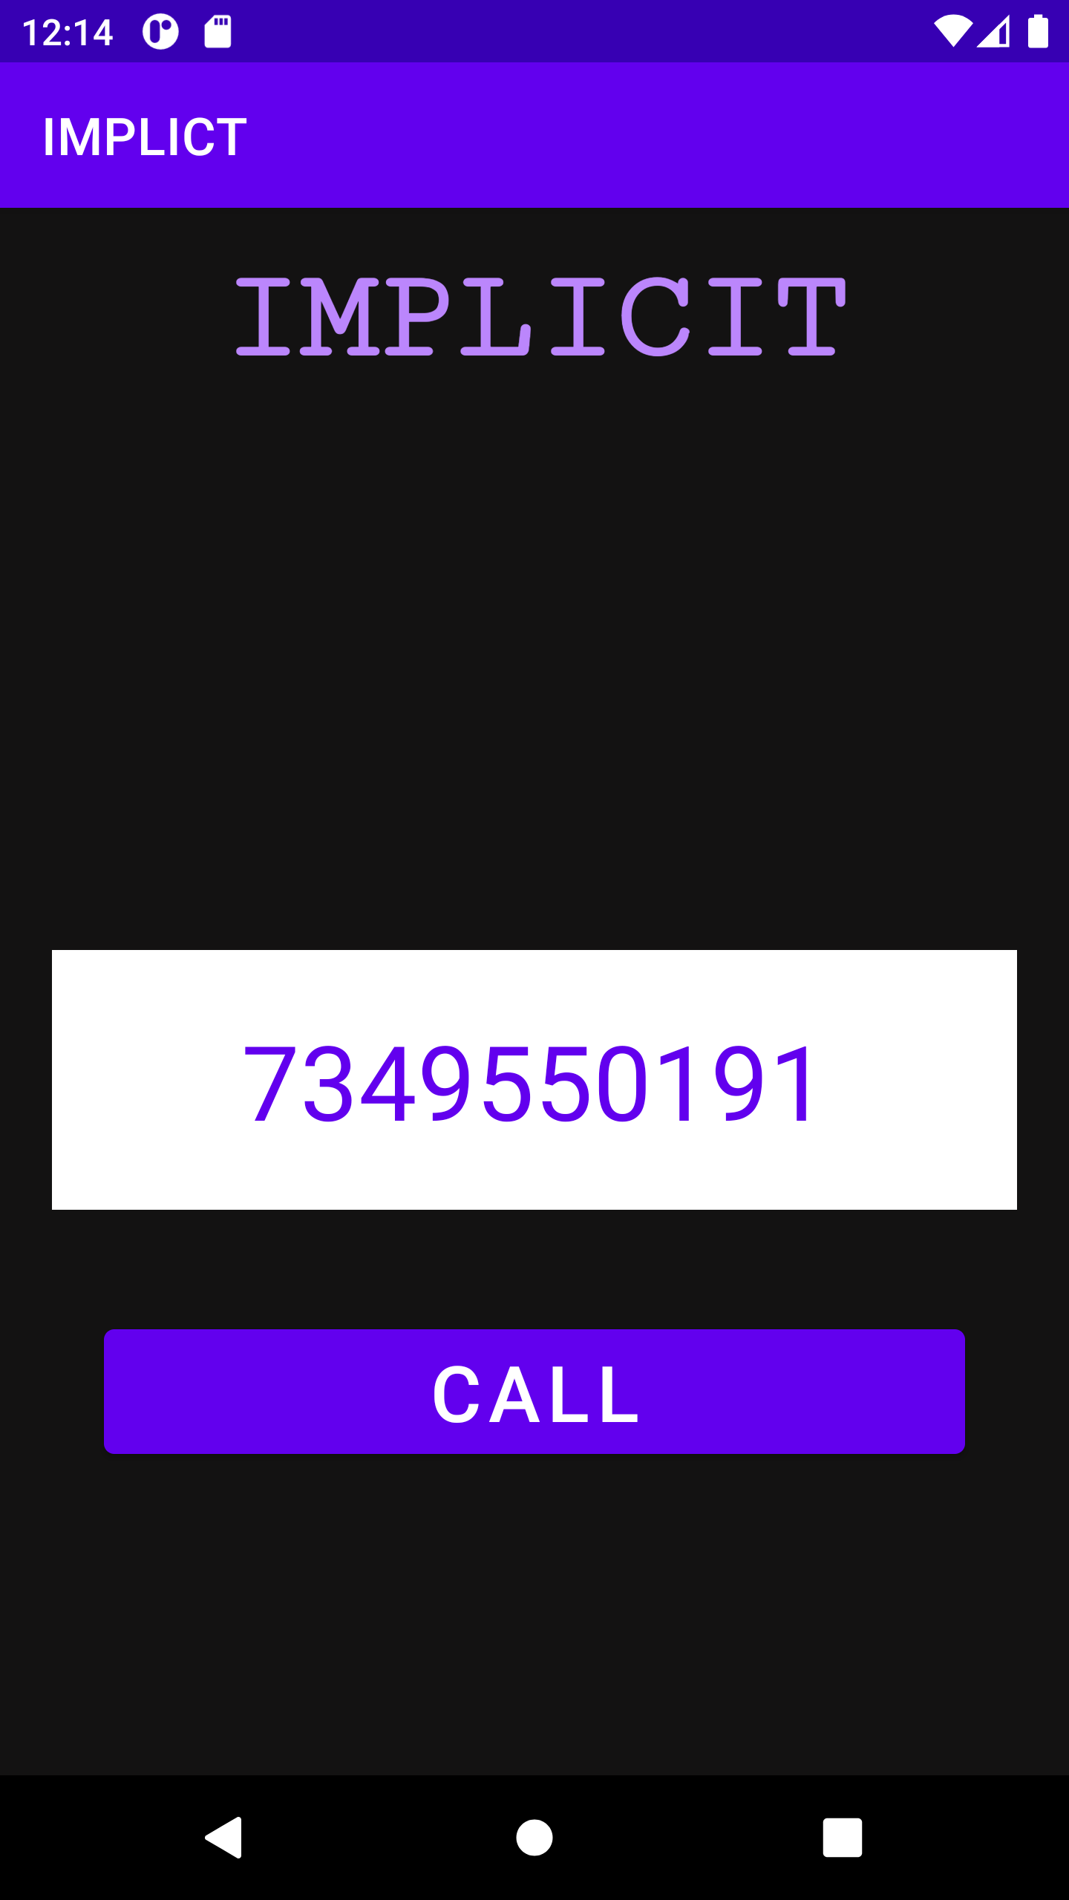

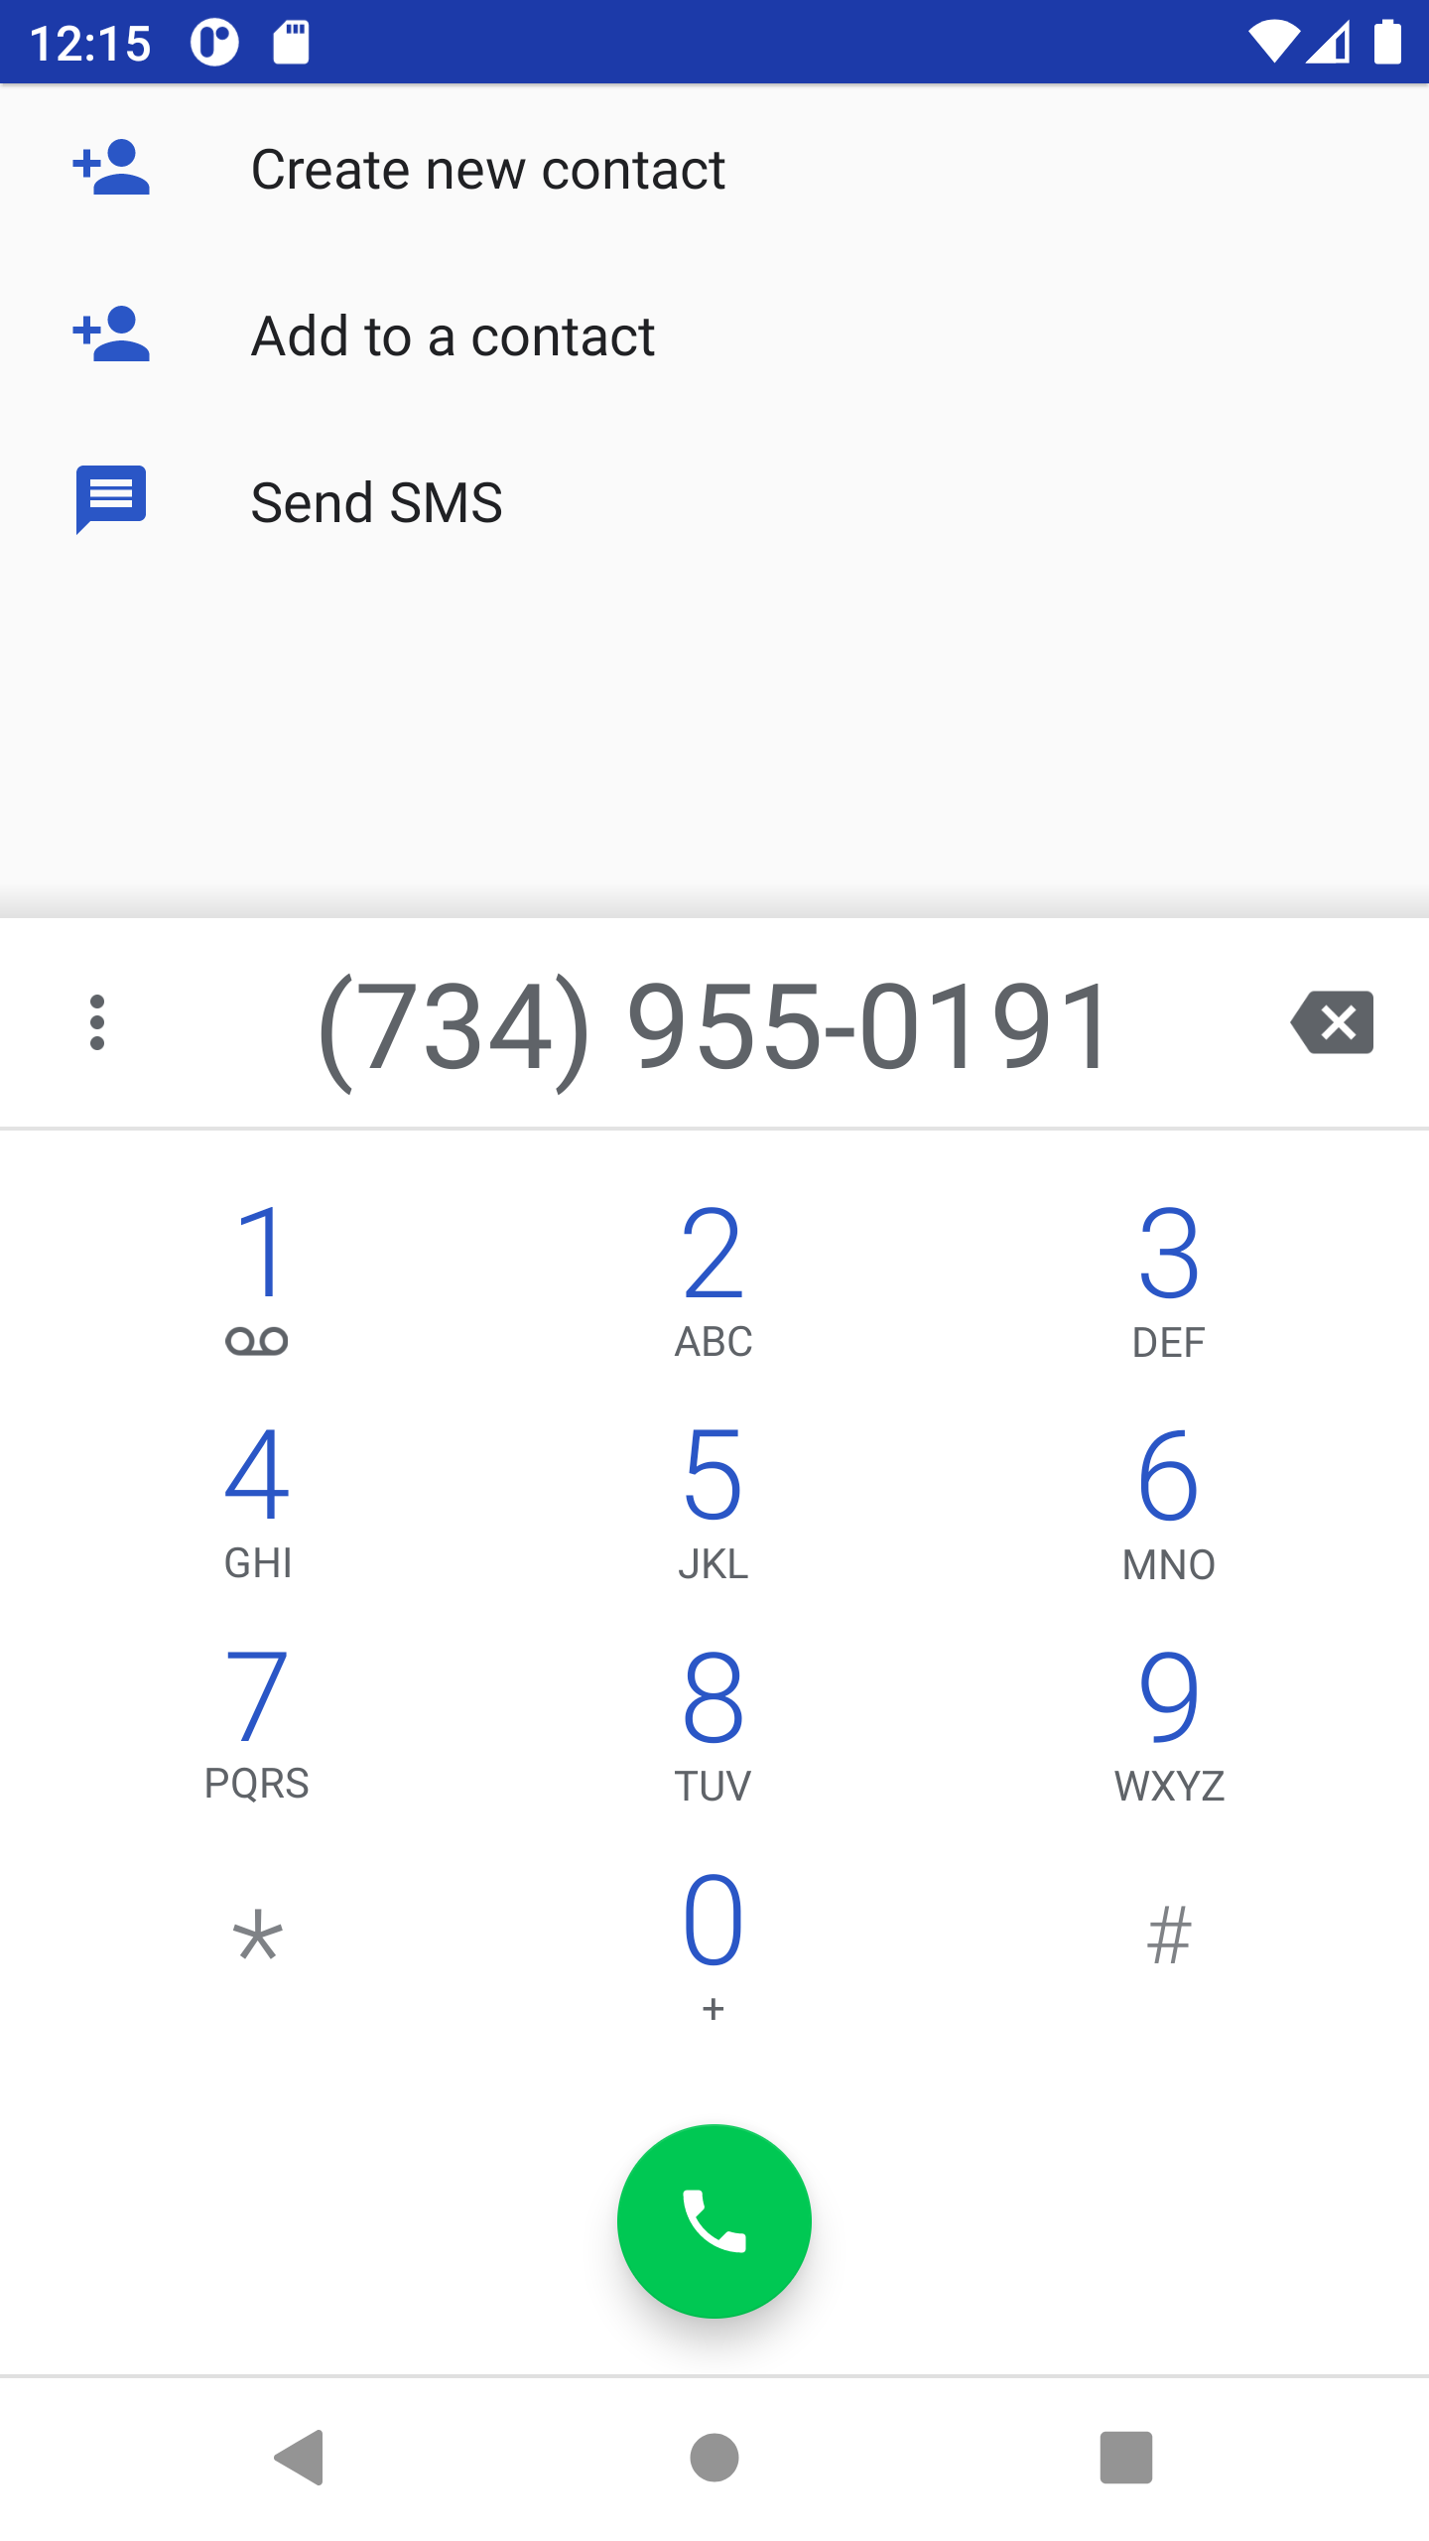

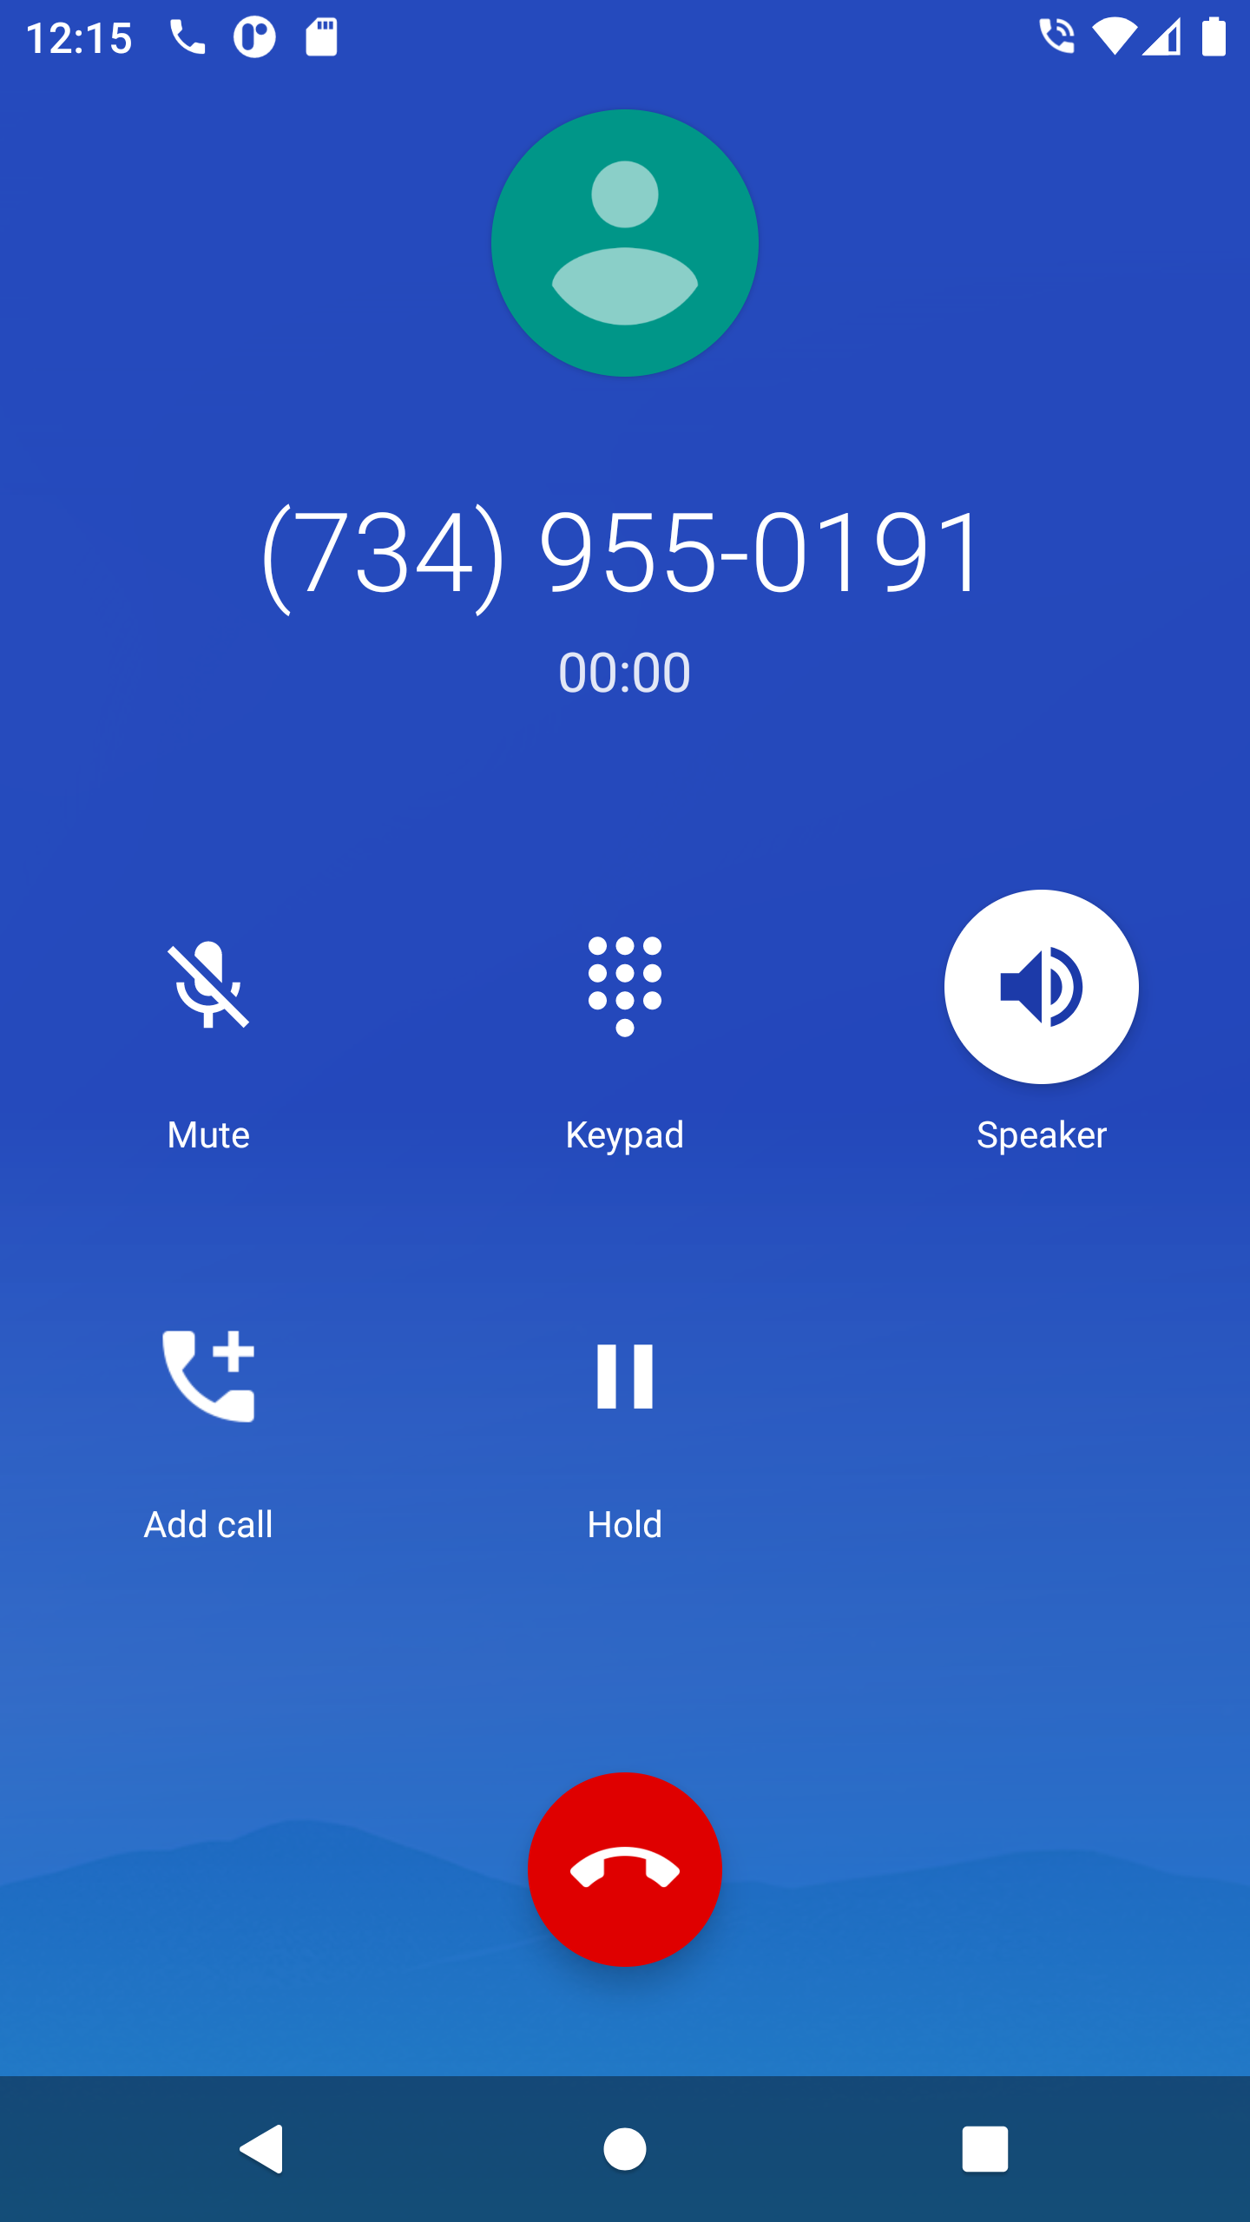
Explicit

XML Code1:
<?xml version="1.0" encoding="utf-8"?>
<LinearLayout xmlns:android="http://schemas.android.com/apk/res/android"
xmlns:app="http://schemas.android.com/apk/res-auto"
xmlns:tools="http://schemas.android.com/tools"
android:layout_width="match_parent"
android:layout_height="match_parent"
android:background="#039BE5"
android:orientation="vertical"
tools:context=".MainActivity">
<TextView
android:layout_width="match_parent"
android:layout_height="wrap_content"
android:layout_marginTop="15dp"
android:layout_marginBottom="15dp"
android:fontFamily="serif"
android:gravity="center"
android:text="EXPLICIT"
android:textColor="@color/white"
android:textSize="50dp"
android:textStyle="bold" />
<EditText
android:id="@+id/text"
android:layout_width="match_parent"
android:layout_height="wrap_content"
android:layout_marginLeft="20dp"
android:layout_marginTop="200dp"
android:layout_marginRight="20dp"
android:background="@color/white"
android:gravity="center"
android:hint="enter your name here"
android:textColor="@color/black"
android:textSize="45dp"
android:textStyle="normal" />
<Button
android:id="@+id/button"
android:layout_width="match_parent"
android:layout_height="wrap_content"
android:layout_margin="35dp"
android:text="CLICK"
android:textStyle="bold"
android:textSize="30dp" />
</LinearLayout>

JAVA CODE: -
package com.example.intent;
import androidx.appcompat.app.AppCompatActivity;
import android.content.Intent;
import android.os.Bundle;
import android.view.View;
import android.widget.Button;
import android.widget.EditText;
public class MainActivity extends AppCompatActivity {
EditText text;
Button button;
@Override
protected void onCreate(Bundle savedInstanceState) {
super.onCreate(savedInstanceState);
setContentView(R.layout.activity_main);
text=findViewById(R.id.text);
button=findViewById(R.id.button);
button.setOnClickListener(new View.OnClickListener() {
@Override
public void onClick(View view) {
Intent it=new Intent(MainActivity.this,secActivity2.class);
Bundle b=new Bundle();
b.putString("text",text.getText().toString());
it.putExtras(b);
startActivity(it);
}
});
}
}

XML Code2:
<?xml version="1.0" encoding="utf-8"?>
<LinearLayout xmlns:android="http://schemas.android.com/apk/res/android"
xmlns:app="http://schemas.android.com/apk/res-auto"
xmlns:tools="http://schemas.android.com/tools"
android:layout_width="match_parent"
android:layout_height="match_parent"
android:background="#039BE5"
tools:context=".secActivity2">
<TextView
android:layout_width="match_parent"
android:layout_height="match_parent"
android:id="@+id/mytext"
android:gravity="center"
android:text="NAME"
android:fontFamily="serif-monospace"
android:textSize="50dp"
android:textStyle="bold"
android:textAlignment="center"
android:textColor="@color/white"
/>
</LinearLayout>

JAVA CODE: -

package com.example.intent;
import androidx.appcompat.app.AppCompatActivity;
import android.os.Bundle;
import android.widget.TextView;
public class secActivity2 extends AppCompatActivity {
TextView t;
String nameFromFirst="";
@Override
protected void onCreate(Bundle savedInstanceState) {
super.onCreate(savedInstanceState);
setContentView(R.layout.activity_sec2);
t=findViewById(R.id.mytext);
nameFromFirst=getIntent().getStringExtra("text");
t.setText(nameFromFirst);
}
}

